Chapter Six: Sensation and Perception
Smell Classroom Learning Activity Directions
Smell Classroom Learning Activity Handout
Ambiguous Figures—Girl/Man Classroom Learning Activity
Ambiguous Figures—Seal/Masquerade Ball Classroom Learning Activity
Mini-Assignment#1—Giving Up A Sense
Mini-Assignment #2—Opponent Processing in Vision
Mini Assignment #3—Divided Attention
Mini Assignment #4—Senses Challenge
Mini Assignment #5—Eye Witness Abilities
Handout # 1 —Review of Sensory Modalities
FOLLOW THESE DIRECTIONS, PLEASE!

1. PICK UP ONE OF THE SHEETS ON THE DESK AS YOU COME INTO THE ROOM.

2. PUT YOUR NAME ON IT.

3. MOVE AROUND THE ROOM TO THE
LOCATIONS WHERE "SMELL BOTTLES" ARE LOCATED. EACH BOTTLE HAS A UNIQUE NUMBER ON IT.

4. SMELL THE BOTTLES (#1-16) AND WRITE
DOWN WHAT YOU THINK THE SMELL IS.

WARNING!!! DO NOT SHAKE THE BOTTLE, TRY TO LOOK INTO IT, OR DO ANYTHING ELSE TO GET CUES OTHER THAN OLFACTORY!
BE CAUTIOUS!!! DO NOT TAKE A BIG WHIFF RIGHT AWAY!!!
SMELL WORKSHEET

1.
2.
3.
4.
5.
6.
7.
8.
9.
10.
11.
12.
13.
14.
15.
16.

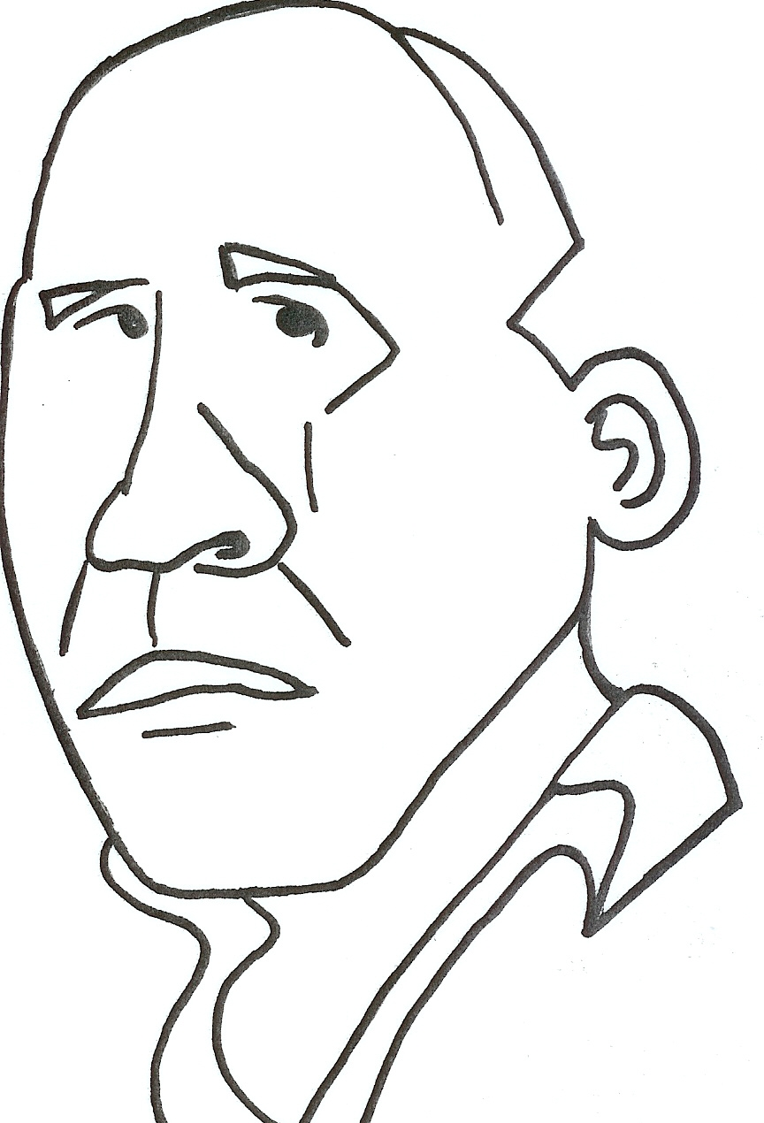 | 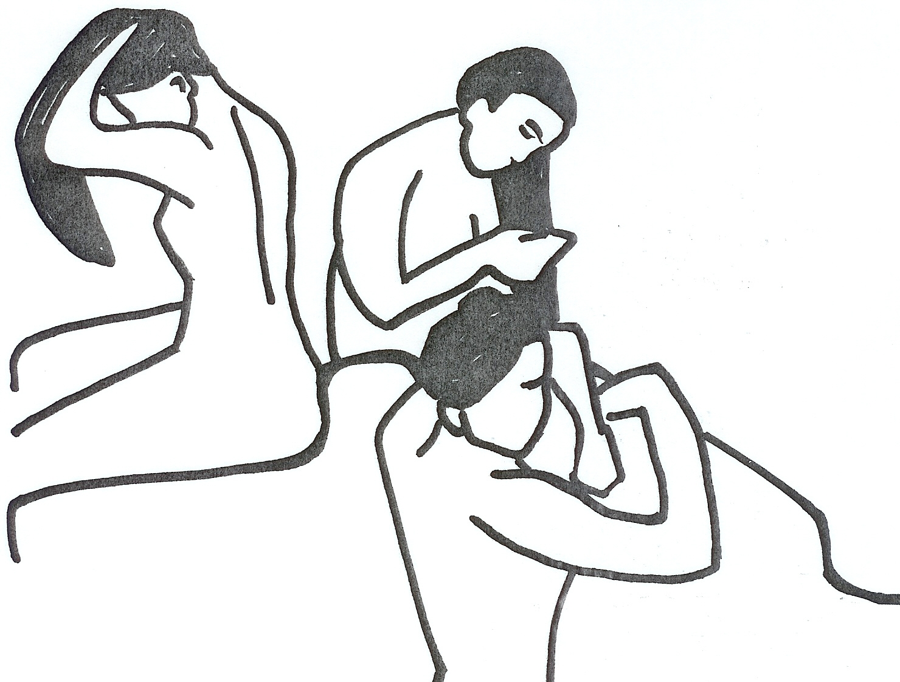
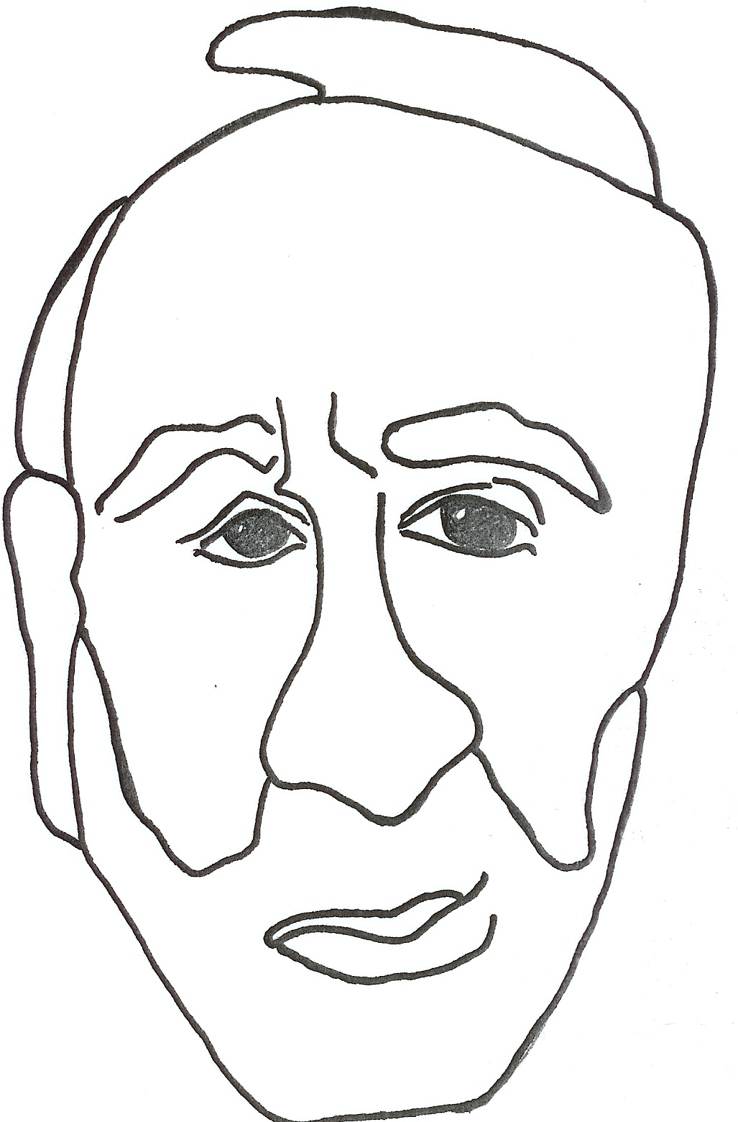 | 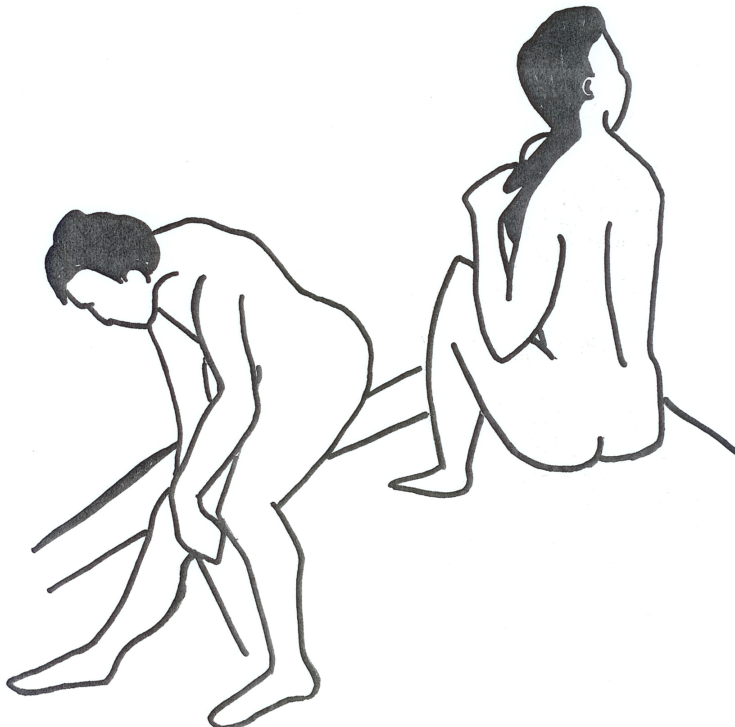
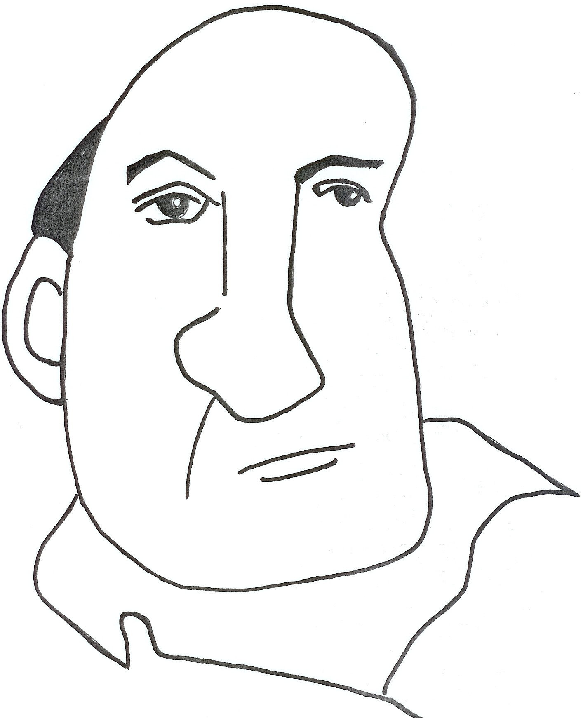 | 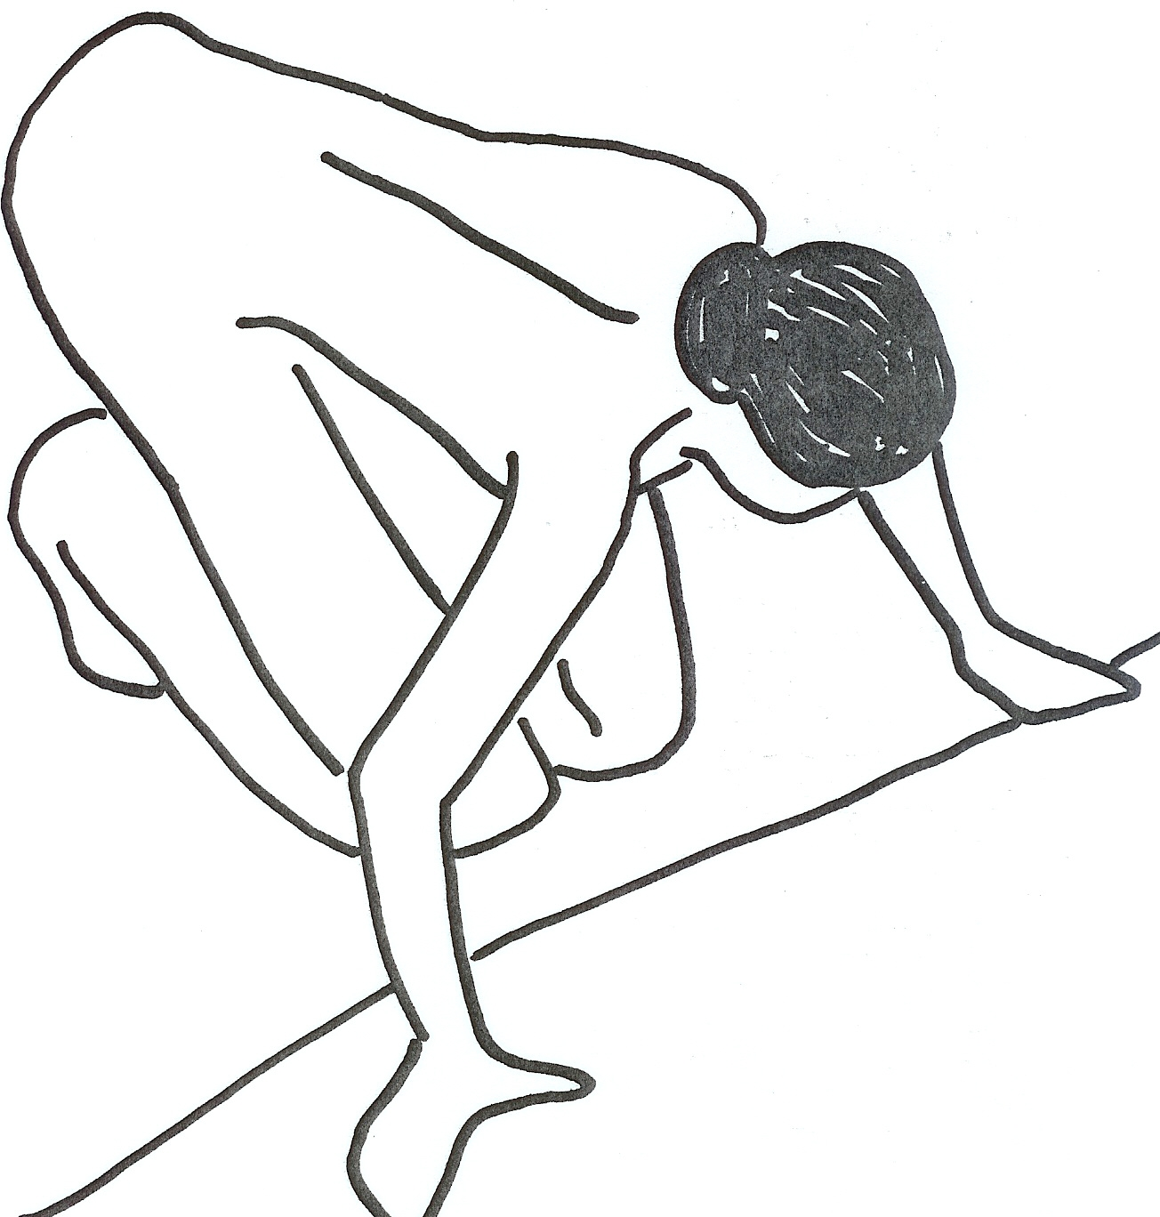
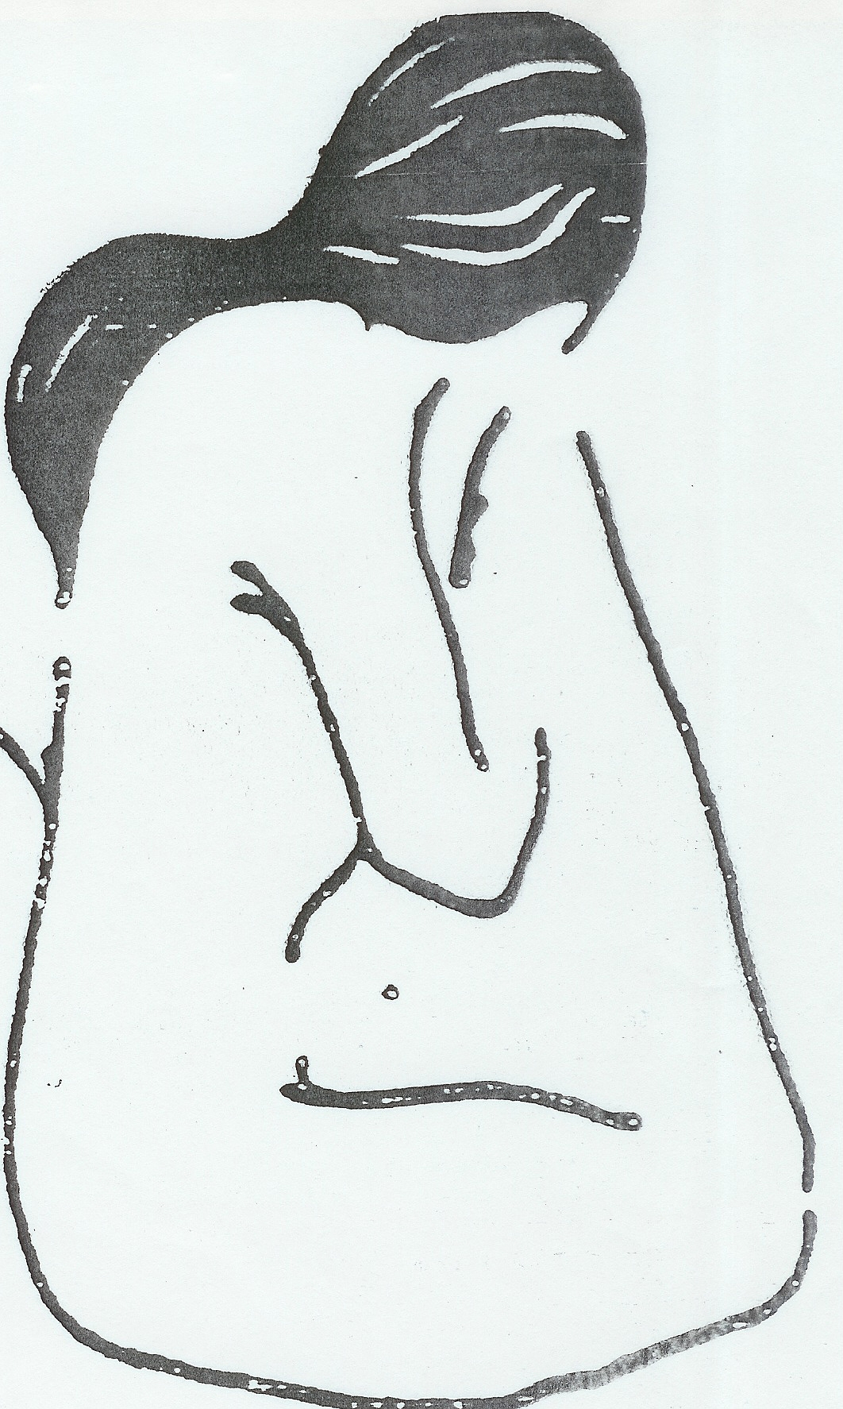
(Permission Houghton Mifflin)
(Permission Houghton Mifflin)

You have been told that you must give up one of your senses.
1. Which one would you choose not to have?
2. Why would you choose this sense and not one of the others?
3. Describe the physiological processes/physical structures that would be affected by your lack of this sense.

Find a television station such as CNN, Fox News, or CNBC that has information continually moving across the bottom of the screen. Concentrate on watching this “crawl” for two minutes. Then look at a stationary object in the room, or at a page of newsprint. Does that object or the page appear to move? In what direction does it move? Write a paragraph describing what you saw and, based on what you have read in the chapter about opponent processes in vision, explain why this illusion occurs.

Listen to a “talk radio” station for about 5 minutes, and jot down the main points being discussed. Next, call a friend on the phone and have a 5-minute conversation while you also try to keep track of the discussion on the radio. When the call is over, try to write down the main points of what you heard on the radio. Compare these notes with the notes you took earlier. Why do you think it was so difficult to keep track of both conversations at once? Would it have been easier to, say, bounce a ball or make a salad while talking on the phone? If so, why? Write a paragraph or two describing the difficulties in dividing attention.

Go to the BBC webpage at http://www.bbc.co.uk/science/humanbody/body/interactives/senseschallenge/ and take the “Senses Challenge”. What was your score? Which questions did you miss? Explain why you missed the question and what the correct answer is. Do this in your own words.

Eye witness testimony, when someone actually sees another person committing a crime, is very influential in trials. However, psychologists have found that many eye witnesses provide incorrect information—sometimes even incorrectly identifying the person who committed the crime. Using the information you learned about perception and attention write a paragraph explaining how an “eye witness” could perceive incorrect information.

Review of Sensory Modalities

Hearing
ENERGY DETECTED: Repeating pressure changes (“sound waves”) of a medium
ACCESSORY STRUCTURES: Pinna, ear canal, tympanic membrane (eardrum), malleus (hammer), incus (anvil), stapes (stirrup), oval window, fluid in cochlea.
SENSORY TRANSDUCTION: Hair cells on basilar membrane of the cochlea bend as fluid moves.
INFORMATION CODING: Sound wave amplitude is coded as loudness, frequency is coded as pitch.
PERIPHERAL PROCESSING: Hair cells -- auditory nerve -->
CENTRAL PROCESSING: Auditory nerve --> contralateral thalamus --> primary auditory cortex
RELATED IDEAS: Pure tones, fundamental frequency, and noise; deafness; frequency matching (volley) and place theories.

Vision
ENERGY DETECTED: Photons.
ACCESSORY STRUCTURES: Cornea, iris (adjusts pupil), lens, fluid in eye.
SENSORY TRANSDUCTION: Photopigment of photoreceptors (rods, cones) in the retina “absorbs” photon energy.
INFORMATION CODING: Light “wave” intensity is coded as brightness, wavelength is coded as color.
PERIPHERAL PROCESSING: Photoreceptors ---> bipolar cells ---> ganglion cells -- optic nerve -->; convergence; blind spot; interneurons give lateral inhibition.
CENTRAL PROCESSING: Optic nerve --> thalamus (lateral geniculate nucleus) --> primary visual cortex, topographical mapping; 50% of optic nerve axons cross at the optic chiasm, so each side of the thalamus receives input from the opposite-sided visual world.
RELATED IDEAS: Color vision; dark adaptation; parallel processing, feature detection, & spatial frequency filter models; receptive fields.

Chemical Senses
ENERGY DETECTED: Volatile (in olfaction) and nonvolatile (in gustation) chemicals.
ACCESSORY STRUCTURES: Nose, mouth, respiratory tract, tongue.
SENSORY TRANSDUCTION: OLFACTION--receptors on cells in upper nose bind specific volatile chemicals.
GUSTATION--taste buds, grouped as papillae in the tongue and throat, bind chemicals in food.
INFORMATION CODING: OLFACTION--
GUSTATION--salty, bitter, sweet, sour, umami, more)
PERIPHERAL PROCESSING:
CENTRAL PROCESSING: OLFACTION-- axons from nose ---> olfactory bulbs ---> many brain areas, especially amygdala
GUSTATION-- involves thalamus
RELATED IDEAS: Pheromones, flavor.

Somatosensation
ENERGY DETECTED: Mechanical deformation or thermal state of skin; muscle and tendon tension (kinesthesia).
ACCESSORY STRUCTURES: Skin, hair, attachments to free nerve endings.
SENSORY TRANSDUCTION: TOUCH--skin deformation or hair movement physically stimulates free nerve endings.
PAIN--skin deformation, heat, cold, or chemical release stimulates A-delta or C fibers.
KINESTHESIA--receptors in joints and muscles transduce stretch.
INFORMATION CODING: Stimulus changes; intensity, location.
PERIPHERAL PROCESSING: Peripheral nerves ---> spinal cord.
CENTRAL PROCESSING: Spinal cord ---> contralateral thalamus ---> primary somatosensory cortex
PAIN--also involves cingulate cortex, reticular formation
KINESTHESIA--also involves cerebellum
RELATED IDEAS: Adaptation, endorphins, analgesia, gate control theory.

Vestibular Sense (Balance)
ENERGY DETECTED: Head position, direction of gravity.
ACCESSORY STRUCTURES: Fluid in semicircular canals and vestibular sacs.
SENSORY TRANSDUCTION: Hair endings in vestibular sacs are stimulated by otoliths, which are bent by gravity. Hair cells in semicircular canals bend with fluid movements due to head position and movement.
INFORMATION CODING: PERIPHERAL PROCESSING: Vestibular receptors --> auditory nerve -->
CENTRAL PROCESSING: Auditory nerve --> cerebellum, hindbrain (control of eye muscles), autonomic nervous system
RELATED IDEAS: Vestibulo-ocular reflexes.

(Permission Houghton Mifflin)

